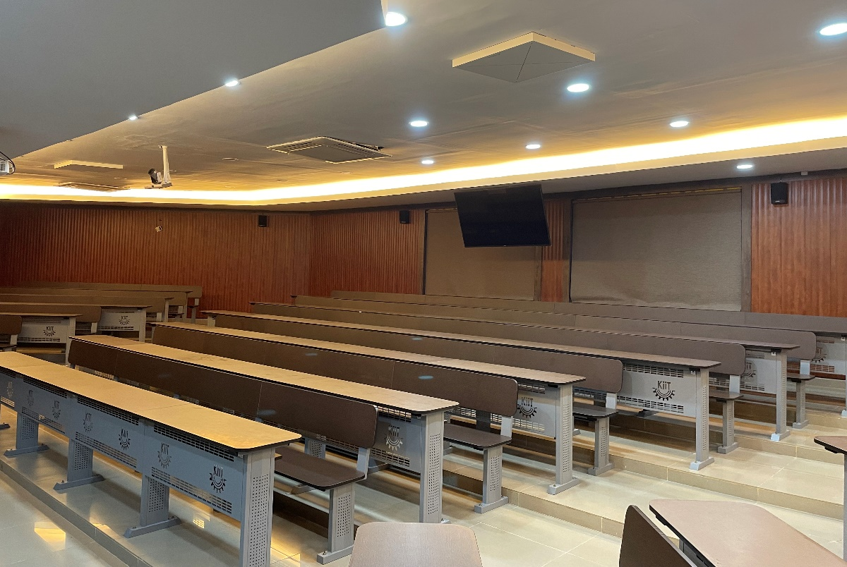

Sennheiser's TeamConnect Ceiling 2 Revolutionizes Hybrid Learning at KIIT Bhubaneswar

150 units of TCC 2 were deployed across the KIIT Bhubaneshwar campus as part of the institution’s journey to a smart campus.

Delhi, 23 October, 2023 – Kalinga Institute of Industrial Technology (KIIT), a renowned and highly sought-after educational institution in Bhubaneswar, India, has selected Sennheiser’s TeamConnect Ceiling 2 microphones to enhance the learning experience across its campuses.

KIIT has 25 lush green campuses that are spread over a vast 25 square-kilometre land space that features world-class infrastructure and facilities to support its mission to deliver quality education and research across various disciplines. In the wake of the global pandemic, the university, like many educational institutions worldwide, faced the same challenge of having to adapt to a hybrid learning model. With a substantial number of students attending classes remotely, KIIT sought a seamless, touchless solution that can mitigate hygiene risks and can serve both on-site and remote students.

Working closely with Sustainable Outreach and University Leadership Limited (SOUL), the project's principal integrator, KIIT found its solution in Sennheiser's TeamConnect Ceiling 2 (TCC 2). The university deployed 150 units of TCC 2, ushering in a flexible, hybrid learning experience that met their unique needs.

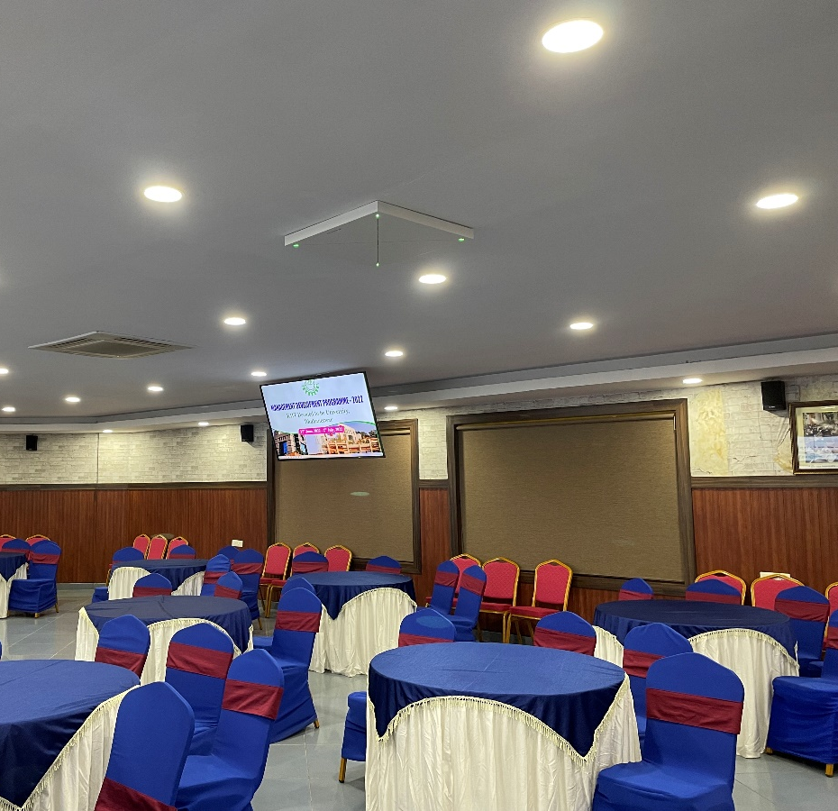
KIIT installed 150 units of Sennheiser TCC 2 to elevate the hybrid learning experience

Customized audio for diverse spaces

The requirements seem straightforward, but the installation had its own set of challenges. Across 150 rooms in the university, each room required specific audio adjustments and settings due to the seating arrangement and layout of each room.

The Sennheiser team and the team of engineers from SOUL played a pivotal role in ensuring the success of this project, and that all the requirements of KIIT were met. They carried out a seamless and hassle-free installation within the stipulated timeframe and delivered an outcome that KIIT was satisfied with.

Sasmita Samanta, Chairperson cum Managing Director, SOUL, commented, “We really appreciate the service and guidance rendered by Sennheiser team and SOUL. They understood what we wanted and simply delivered. Our instructors and students, regardless of whether they are on-site and remote, can now focus on learning and teaching without any disruptions.”

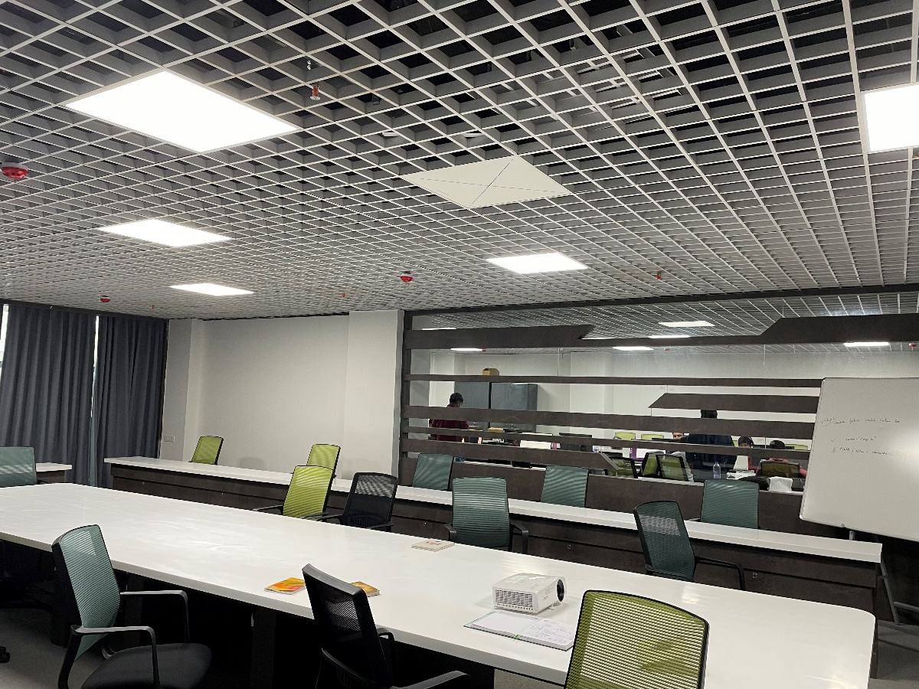
The installation of TCC 2 was seamless and delivered and outcome that the KIIT team was satisfied with

“The audio clarity is excellent, and we received feedback from students that it felt like they were physically in the classroom even when they were participating remotely! The TruVoicelift functionality and the speech intelligibility of the Sennheiser TCC 2 are indeed game changers,” said Pradeep Kumar Mallick, Associate Professor at KIIT’s School of Computer Engineering.

KIIT's Journey to a Smart Campus

Established in 1992, KIIT has grown from a modest industrial training institute into a thriving world-class university, offering a wide spectrum of undergraduate, postgraduate, and doctoral courses.

Since 2020, KIIT has been on a transformative journey to convert its campus into a smart campus through partnerships with leading industry brands. "Furnishing our campus with Sennheiser's products has significantly enhanced the quality of our educational offerings," shared Samita Samanta, Vice Chancellor of KIIT.

Naveen Sridhara, Director of Sales, Business Communication at Sennheiser India, added, “I am thrilled to witness the role that Sennheiser’s TCC 2 has played in KIIT’s journey to smart campus. At Sennheiser, we are committed to building the future of audio and creating audio solutions that can better serve our end-users.”

About the brand Sennheiser
We live and breathe audio. We are driven by the passion to create audio solutions that make a difference. Building the future of audio and bringing remarkable sound experiences to our customers – this is what the Sennheiser brand has stood for since more than 75 years. While professional audio solutions such as microphones, conference systems, streaming technologies and monitoring systems are part of the business of Sennheiser electronic GmbH & Co. KG, the business with consumer devices such as headphones, soundbars and speech-enhanced hearables is operated by Sonova Holding AG under the license of Sennheiser.

www.sennheiser.com
www.sennheiser-hearing.com

Press Contacts

Jeff Horan
Global PR/Media Manager Business Communication
jeffrey.horan@sennheiser.com
M +1 860-598-7539

Phang Su Hui
Communications Manager, APAC
suhui.phang@sennheiser.com
M +65 91595024

